FEEDBACK_FUNCTIONAL MODELS

Use Case Diagram

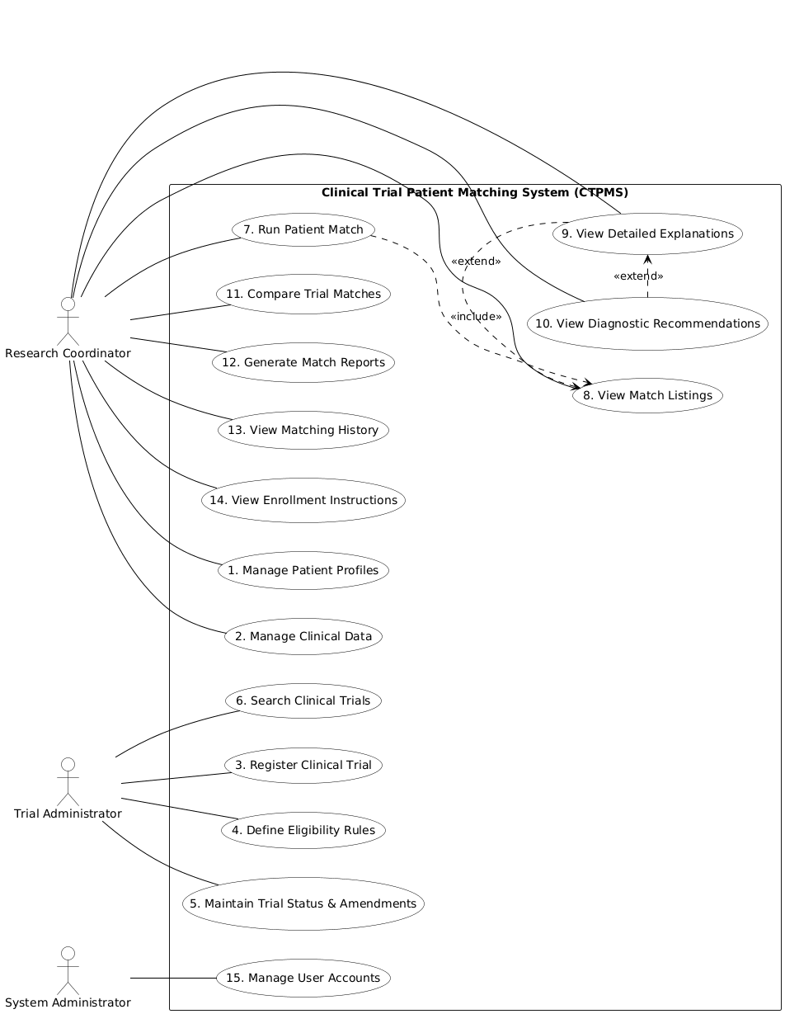

2. Use Case Description

UC-01: Manage Patient Profiles
Use Case Name: Manage Patient Profiles | ID: UC-01 | Importance Level: High
Primary Actor: Research Coordinator | Use Case Type: Detail
Stakeholders and Interests: | Research Coordinator: Needs to efficiently onboard patients to the system.  Patient: Wants their demographic info accurately recorded.
Brief Description: | The Research Coordinator creates, updates, searches for, or deactivates patient profiles within the system.  User Requirements Addressed: 1, 8, 9
Pre-conditions: | Coordinator is authenticated and has "Coordinator" permissions.
Post-conditions: | Patient profile is created, updated, or marked as inactive in the database.
Trigger: | Coordinator initiates patient management task. | Type: External
Relationships: | Association: Coordinator  Include: None  Extend: None  Generalization: None
Normal Flow of Events: | 1. Coordinator logs into the system.  2. Coordinator selects "Patient Management."  3. System displays options to Create, Search, or View list.  4. Coordinator enters patient demographic details (ID, DOB, gender, ethnicity).  5. Coordinator saves the profile.  6. System validates and stores the patient record.
Sub Flows: | S-1 (Search): Coordinator enters Patient ID or Name; System returns matching profile.  S-2 (Deactivate): Coordinator selects "Deactivate"; System marks profile as inactive.
Alternate / Exceptional Flows: | E-1: Patient ID already exists. System displays error "Duplicate ID" and prompts for correction.

UC-02: Manage Clinical Data
Use Case Name: Manage Clinical Data | ID: UC-02 | Importance Level: High
Primary Actor: Research Coordinator | Use Case Type: Detail
Stakeholders and Interests: | Research Coordinator: Needs to input complex medical history for accurate matching.  Trial Admin: Needs accurate data to ensure eligibility rules work.
Brief Description: | The coordinator adds or updates diagnoses, medications, lab results, history, genetic markers, and performance scores for a patient.  User Requirements Addressed: 2, 3, 4, 5, 6, 7
Pre-conditions: | Patient profile (UC-01) must exist. Coordinator is authenticated.
Post-conditions: | Patient’s clinical data is updated and encrypted in the system.
Trigger: | Coordinator accesses a patient profile to update medical info. | Type: External
Relationships: | Association: Coordinator  Include: None  Extend: None  Generalization: None
Normal Flow of Events: | 1. Coordinator searches for and selects a specific patient (ref UC-01).  2. Coordinator navigates to the "Clinical Data" tab.  3. Coordinator selects data type (e.g., Diagnosis, Medication, Lab Result).  4. Coordinator enters specific details (e.g., ICD-10 code, drug dosage, ECOG score).  5. System encrypts (AES-256) and saves the data.
Sub Flows: | S-1: Coordinator deletes an incorrect entry.  S-2: Coordinator updates a Lab Result value.
Alternate / Exceptional Flows: | E-1: Invalid ICD-10 code entered. System validates against WHO database and rejects invalid code.

UC-03: Register Clinical Trial
Use Case Name: Register Clinical Trial | ID: UC-03 | Importance Level: High
Primary Actor: Trial Administrator | Use Case Type: Detail
Stakeholders and Interests: | Trial Admin: Needs to add new trials to the database.  Sponsor: Needs their trial visible for recruitment.
Brief Description: | The Trial Administrator registers a new clinical trial by entering identification, protocol numbers, and logistics information.  User Requirements Addressed: 10, 11, 16
Pre-conditions: | Administrator is authenticated with "Trial Admin" permissions.
Post-conditions: | A new trial record is created in the database with an "Inactive" or "Pending" status.
Trigger: | New trial protocol received. | Type: External
Relationships: | Association: Trial Administrator  Include: None  Extend: None  Generalization: None
Normal Flow of Events: | 1. Administrator selects "Add New Trial."  2. Administrator enters Protocol Number, NCT Number, Title, and Phase.  3. Administrator selects the Disease Focus (ICD-10).  4. Administrator enters logistics (Sites, Target Enrollment, Contact Info).  5. System saves the new trial record.
Sub Flows: | None
Alternate / Exceptional Flows: | E-1: NCT Number format is incorrect. System prompts for valid format.

UC-04: Define Eligibility Rules
Use Case Name: Define Eligibility Rules | ID: UC-04 | Importance Level: Critical
Primary Actor: Trial Administrator | Use Case Type: Detail
Stakeholders and Interests: | Trial Admin: Needs to translate text protocols into logic.  System: Needs structured rules to perform automated matching.
Brief Description: | The Administrator defines inclusion/exclusion criteria using structured rules, logical operators (AND/OR), and assigns importance weights.  User Requirements Addressed: 12, 13, 14, 15
Pre-conditions: | Trial registration (UC-03) exists.
Post-conditions: | Logic rules are mapped to the specific trial and ready for the matching engine.
Trigger: | Trial registration completion or update. | Type: External
Relationships: | Association: Trial Administrator  Include: None  Extend: None  Generalization: None
Normal Flow of Events: | 1. Administrator opens a registered trial.  2. Administrator selects "Criteria Configuration."  3. Administrator defines Inclusion rules (e.g., "Age > 18", "Biomarker Positive").  4. Administrator defines Exclusion rules (e.g., "Prior Surgery = True").  5. Administrator links rules using AND/OR logic.  6. Administrator assigns weights (1-5) to criteria.  7. System saves the rule set.
Sub Flows: | None
Alternate / Exceptional Flows: | E-1: Logical conflict detected (e.g., Age > 18 AND Age < 10). System warns user.

UC-05: Maintain Trial Status & Amendments
Use Case Name: Maintain Trial Status | ID: UC-05 | Importance Level: Medium
Primary Actor: Trial Administrator | Use Case Type: Detail
Stakeholders and Interests: | Trial Admin: Ensures system reflects current reality (e.g., if recruitment stops).
Brief Description: | The Administrator updates the status of a trial (e.g., Active-Enrolling to Suspended) or updates criteria based on protocol amendments.  User Requirements Addressed: 17, 18
Pre-conditions: | Trial record exists in the system.
Post-conditions: | Trial status is updated; visibility in matching results is adjusted.
Trigger: | Protocol amendment or recruitment status change. | Type: External
Relationships: | Association: Trial Administrator  Include: None  Extend: UC-04 | Generalization: None
Normal Flow of Events: | 1. Administrator searches for the specific trial.  2. Administrator selects "Update Status."  3. Administrator chooses new status from dropdown (e.g., "Suspended").  4. System updates the trial visibility.  5. (Optional) Administrator edits criteria to reflect amendments.  6. System saves changes.
Sub Flows: | None
Alternate / Exceptional Flows: | E-1: Attempting to set status to "Active" without defined criteria. System blocks action.

UC-06: Search Clinical Trials
Use Case Name: Search Clinical Trials | ID: UC-06 | Importance Level: Low
Primary Actor: Trial Administrator | Use Case Type: Detail
Stakeholders and Interests: | Trial Admin: Needs to locate specific trials to edit or review.
Brief Description: | The Administrator searches for trials using protocol number, keywords, sponsor, or disease focus.  User Requirements Addressed: 19
Pre-conditions: | Database contains registered trials.
Post-conditions: | List of trials matching criteria is displayed.
Trigger: | Need to modify or view trial data. | Type: External
Relationships: | Association: Trial Administrator  Include: None  Extend: None  Generalization: None
Normal Flow of Events: | 1. Administrator navigates to "Trial Search."  2. Administrator enters search keywords (e.g., "Lung Cancer").  3. System queries the database.  4. System displays a list of matching trials.
Sub Flows: | None
Alternate / Exceptional Flows: | E-1: No trials found. System displays "No records match your criteria."

UC-07: Run Patient Match
Use Case Name: Run Patient Match | ID: UC-07 | Importance Level: Critical
Primary Actor: Research Coordinator | Use Case Type: Detail
Stakeholders and Interests: | Research Coordinator: Wants to find trials for a patient.  Patient: Wants to know if they qualify for treatment.
Brief Description: | The Coordinator initiates the automated matching algorithm to compare a selected patient profile against all active clinical trials.  User Requirements Addressed: 20
Pre-conditions: | Patient clinical data exists. Active trials with rules exist in system.
Post-conditions: | Matching scores are calculated and stored for the current session.
Trigger: | Coordinator initiates "Run Match" on patient record. | Type: External
Relationships: | Association: Research Coordinator  Include: UC-08 | Generalization: None
Normal Flow of Events: | 1. Coordinator selects a patient profile.  2. Coordinator clicks "Initiate Matching."  3. System retrieves all "Active" trials.  4. System compares patient data against trial logic rules (NFR-1: <5 seconds).  5. System calculates scores.  6. System initiates "View Match Listings" (UC-08).
Sub Flows: | None
Alternate / Exceptional Flows: | E-1: Patient data is insufficient to run any rules. System prompts to add Clinical Data (UC-02).

UC-08: View Match Listings
Use Case Name: View Match Listings | ID: UC-08 | Importance Level: High
Primary Actor: Research Coordinator | Use Case Type: Detail
Stakeholders and Interests: | Research Coordinator: Needs a prioritized list to filter options quickly.
Brief Description: | The coordinator views the results of the matching process, ranked by score, with categories (Strong, Potential, Weak) and confidence scores.  User Requirements Addressed: 21, 22, 23
Pre-conditions: | UC-07 has been successfully executed.
Post-conditions: | Ranked list is presented to the user.
Trigger: | Matching process completes. | Type: Temporal
Relationships: | Association: Research Coordinator  Include: None  Extend: None  Generalization: None
Normal Flow of Events: | 1. System displays a dashboard of trials.  2. Trials are sorted by Match Score (Highest to Lowest).  3. Rows are color-coded (Green/Yellow/Red) per NFR-6.  4. Coordinator views the Match Category and Confidence Score for each row.
Sub Flows: | None
Alternate / Exceptional Flows: | None

UC-09: View Detailed Explanations
Use Case Name: View Detailed Explanations | ID: UC-09 | Importance Level: High
Primary Actor: Research Coordinator | Use Case Type: Detail
Stakeholders and Interests: | Research Coordinator: Needs to understand why a patient matched or failed.
Brief Description: | The coordinator drills down into a specific match to see which criteria were met, not met, or missing data.  User Requirements Addressed: 24, 25, 26
Pre-conditions: | Match listings (UC-08) are visible.
Post-conditions: | Detailed logic evaluation for a specific trial is displayed.
Trigger: | Coordinator selects a specific trial match to review. | Type: External
Relationships: | Association: Research Coordinator  Include: None  Extend: UC-10 | Generalization: None
Normal Flow of Events: | 1. Coordinator clicks "Details" on a specific trial match.  2. System displays the list of Inclusion Criteria (Met/Not Met).  3. System displays the list of Exclusion Criteria (Satisfied/Not Satisfied).  4. System shows the specific patient data point next to the rule.
Sub Flows: | None
Alternate / Exceptional Flows: | None

UC-10: View Diagnostic Recommendations
Use Case Name: View Recommendations | ID: UC-10 | Importance Level: Medium
Primary Actor: Research Coordinator | Use Case Type: Detail
Stakeholders and Interests: | Research Coordinator: Needs to know what tests to order to confirm eligibility.
Brief Description: | The system suggests additional data collection or diagnostic tests required to resolve "Unknown" criteria and improve match accuracy.  User Requirements Addressed: 27
Pre-conditions: | UC-09 shows "Unknown" status for certain criteria.
Post-conditions: | List of suggested medical actions/tests is provided.
Trigger: | Missing data detected during match explanation. | Type: External
Relationships: | Association: Research Coordinator  Include: None  Extend: None  Generalization: None
Normal Flow of Events: | 1. Coordinator is viewing detailed match explanations (UC-09).  2. System identifies criteria evaluated as "Unknown" due to missing data.  3. System displays a "Recommendations" panel.  4. System lists specific tests needed (e.g., "Order EGFR Mutation Test").
Sub Flows: | None
Alternate / Exceptional Flows: | None

UC-11: Compare Trial Matches
Use Case Name: Compare Trial Matches | ID: UC-11 | Importance Level: Medium
Primary Actor: Research Coordinator | Use Case Type: Detail
Stakeholders and Interests: | Research Coordinator: Needs to decide between two competing trials.
Brief Description: | The coordinator selects multiple trials to view their match explanations side-by-side to determine the best option.  User Requirements Addressed: 28
Pre-conditions: | Multiple trials are present in the match result list (UC-08).
Post-conditions: | Side-by-side comparison matrix is displayed.
Trigger: | Coordinator chooses to compare matches. | Type: External
Relationships: | Association: Research Coordinator  Include: None  Extend: None  Generalization: None
Normal Flow of Events: | 1. Coordinator checks checkboxes next to 2 or more trials in the result list.  2. Coordinator clicks "Compare."  3. System displays a side-by-side table.  4. Rows show criteria and status (Met/Not Met) for each selected trial.
Sub Flows: | None
Alternate / Exceptional Flows: | E-1: Coordinator selects > 4 trials. System warns "Maximum comparison limit is 4."

UC-12: Generate Match Reports
Use Case Name: Generate Match Reports | ID: UC-12 | Importance Level: Medium
Primary Actor: Research Coordinator | Use Case Type: Detail
Stakeholders and Interests: | Research Coordinator: Needs a document for the physician or patient file.
Brief Description: | The coordinator generates a comprehensive summary of the patient's eligibility and exports it to PDF.  User Requirements Addressed: 29, 30
Pre-conditions: | Matching process (UC-07) has been completed.
Post-conditions: | PDF file is generated and downloaded to local machine.
Trigger: | Request for physical/digital export of results. | Type: External
Relationships: | Association: Research Coordinator  Include: None  Extend: None  Generalization: None
Normal Flow of Events: | 1. Coordinator clicks "Export Report."  2. System compiles patient summary and match results.  3. System formats the document with Qualifying/Disqualifying factors.  4. System downloads the file as a PDF.
Sub Flows: | None
Alternate / Exceptional Flows: | None

UC-13: View Matching History
Use Case Name: View Matching History | ID: UC-13 | Importance Level: Low
Primary Actor: Research Coordinator | Use Case Type: Detail
Stakeholders and Interests: | Research Coordinator: Tracks work over time.
Brief Description: | The coordinator views a log of previous matching sessions performed for a specific patient, including dates and past results.  User Requirements Addressed: 31
Pre-conditions: | System contains historical matching records for the selected patient.
Post-conditions: | Historical session data is retrieved and displayed.
Trigger: | Audit or review of previous patient assessments. | Type: External
Relationships: | Association: Research Coordinator  Include: None  Extend: None  Generalization: None
Normal Flow of Events: | 1. Coordinator navigates to patient history.  2. System displays list of past activities (timestamped).  3. Coordinator can click a past session to view those specific results.
Sub Flows: | None
Alternate / Exceptional Flows: | None

UC-14: View Enrollment Instructions
Use Case Name: View Enrollment Info | ID: UC-14 | Importance Level: Medium
Primary Actor: Research Coordinator | Use Case Type: Detail
Stakeholders and Interests: | Research Coordinator: Needs to know who to call to enroll the patient.
Brief Description: | The coordinator views contact information and specific enrollment instructions for trials categorized as Strong or Potential matches.  User Requirements Addressed: 32
Pre-conditions: | High-confidence match (UC-08) has been identified.
Post-conditions: | Logistics and contact data for the trial site are revealed.
Trigger: | Successful match identified. | Type: External
Relationships: | Association: Research Coordinator  Include: None  Extend: None  Generalization: None
Normal Flow of Events: | 1. Coordinator selects a "Strong Match" trial.  2. Coordinator clicks "Enrollment Info."  3. System displays Principal Investigator name, phone, email, and specific site instructions.
Sub Flows: | None
Alternate / Exceptional Flows: | None

UC-15: Manage User Accounts
Use Case Name: Manage User Accounts | ID: UC-15 | Importance Level: High
Primary Actor: System Administrator | Use Case Type: Detail
Stakeholders and Interests: | System Admin: Maintains system security and access.  Organization: Ensures only authorized staff access patient data.
Brief Description: | The System Administrator creates, updates, or deletes user accounts, assigns roles (RBAC), and resets passwords.  User Requirements Addressed: 33, 34, 35
Pre-conditions: | User is logged in as "System Administrator."
Post-conditions: | User credentials/permissions are updated in the IAM database.
Trigger: | Staffing changes or password reset request. | Type: External
Relationships: | Association: System Administrator  Include: None  Extend: None  Generalization: None
Normal Flow of Events: | 1. Admin logs in.  2. Admin selects "User Management."  3. Admin enters user details (Name, Email).  4. Admin assigns Role (Coordinator, Trial Admin, System Admin).  5. System creates account and sends temporary credentials.
Sub Flows: | S-1 (Reset Password): Admin selects user, clicks "Reset Password." System emails reset link.
Alternate / Exceptional Flows: | E-1: Email already registered. System rejects creation.

3. Activity Diagram with swim lanes
